**Department of Electrical Engineering and   
Computer Science**

**Faculty Member:** Dr. Rehan Ahmed  **Dated:** 22/02/2023

**Semester:**  6th **Section:** BEE 12C

**EE-421:** **Digital System Design**

**Lab 3: Combinational - Circuits Building Blocks**

Group Members

|  |  |  |  |  |  |  |
| --- | --- | --- | --- | --- | --- | --- |
|  |  | **PLO4-CLO3** | | **PLO5 -CLO4** | **PLO8 -CLO5** | **PLO9 -CLO6** |
| **Name** | **Reg. No** | **Viva / Quiz / Lab Performance** | **Analysis of data in Lab Report** | **Modern Tool Usage** | **Ethics and Safety** | **Individual and Teamwork** |
|  |  | **5 Marks** | **5 Marks** | **5 Marks** | **5 Marks** | **5 Marks** |
| Danial Ahmad | 331388 |  |  |  |  |  |
| Muhammad Umer | 345834 |  |  |  |  |  |
| Tariq Umar | 334943 |  |  |  |  |  |

**Table of Contents**

2 Combinational - Circuits Building Blocks 3

2.1 Objectives 3

2.2 Introduction 3

2.3 Software 3

3 Lab Procedure 4

3.1 Part I 4

3.2 Part II 7

3.3 Part III 10

3.4 Part IV 14

4 Conclusion 16

# Combinational - Circuits Building Blocks

## Objectives

The purpose of this exercise is to learn how to design combinational circuits that can perform binary-to-decimal number conversion and binary-coded-decimal (BCD) addition. We will use the switches on the DE-series boards as inputs to the circuit. We will use light emitting diodes (LEDs) and 7-segment displays as output devices.

## Introduction

The use of combination circuits is ubiquitous in the field of electronics, particularly in digital electronics. These circuits are designed to perform logical operations using input signals, producing an output signal based on the logical conditions. A combinational circuit's output depends solely on its input signals, and it has no memory of previous inputs. Through this lab exercise, we aim to gain a practical understanding of how combination circuits work and how they can be used to perform binary-to-decimal number conversion and binary-coded-decimal (BCD) addition. We will also gain experience with Quartus Prime and learn how to use it to design and test digital circuits.

## Software

Quartus Prime is a comprehensive design software developed by Intel Corporation for designing digital circuits using Field-Programmable Gate Arrays (FPGAs). It is a leading software platform in the field of digital design, offering a range of advanced tools and features that enable users to easily create, debug, and verify complex digital circuits. With Quartus Prime, users can benefit from a streamlined design flow that facilitates the creation of digital circuits from concept to implementation. It provides an intuitive graphical user interface that allows users to easily design, test, and debug their circuits. Additionally, Quartus Prime supports a variety of popular programming languages, making it a versatile platform for digital designers of all levels.

# Lab Procedure

## Part I

You are to design a circuit that converts a four-bit binary number V = v3v2v1v0 into its two-digit decimal equivalent D = d1d0. Table 1 shows the required output values. A partial design of this circuit is given in Figure 1. It includes a comparator that checks when the value of V is greater than 9 and uses the output of this comparator in the control of the 7-segment displays.

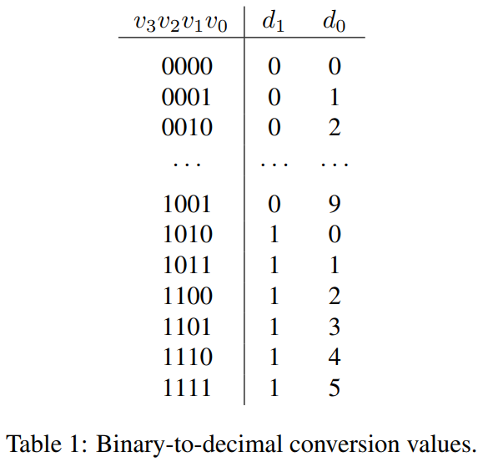

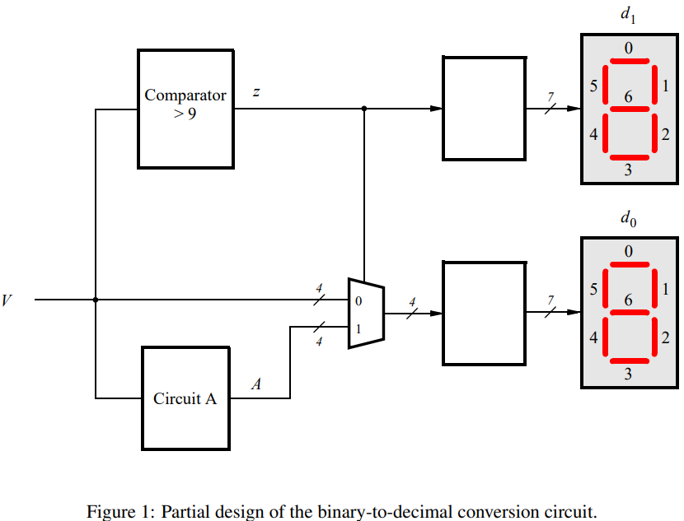

1. Write Verilog code to implement your design. The code should have the 4-bit input SW3−0, which should be used to provide the binary number V, and the two 7-bit outputs HEX1 and HEX0, to show the values of decimal digits d1 and d0. The intent of this exercise is to use simple Verilog assign statements to specify the required logic functions using Boolean expressions. Your Verilog code should not include any if-else, case, or similar statements.
2. Make a Quartus project for your Verilog module.
3. Compile the circuit and use functional simulation to verify the correct operation of your comparator, multiplexers, and circuit A.
4. Download the circuit into an FPGA board. Test the circuit by trying all possible values of V and observing the output displays.

module *task_1* (

*input*  [9:0] SW,

*output* [6:0] HEX0,

*output* [6:0] HEX1

);

   wire [3:0] v = SW[3:0];

   wire [3:0] a, m;

   wire [3:0] z;

   assign z[3:1] = 3'b000;

*circuit_a* circuitA (

       .v(v),

       .a(a)

   );

*comparator* comp (

       .v(v),

       .z(z[0])

   );

*mux_2to1* #(

       .n(3)

   ) mux (

       .a(v),

       .b(a),

       .s(z[0]),

       .m(m)

   );

*decoder* digit0 (

       .v  (m),

       .hex(HEX0)

   );

*decoder* digit1 (

       .v  (z),

       .hex(HEX1)

   );

endmodule

module *mux_2to1* #(

    parameter n = 4

) (

*input* [n:0] a,

*input* [n:0] b,

*input* s,

*output* reg [n:0] m

);

   integer i;

   always @(*)

      for (i = 0; i <= n; i = i + 1) begin

         m[i] = (a[i] & ~s) | (b[i] & s);

      end

endmodule

module *comparator* ( // > 9 comparator

*input* [3:0] v,

*output* z

);

   assign z = v[3] & (v[2] | v[1]);

endmodule

module *circuit_a* (

*input*  [3:0] v,

*output* [3:0] a

);

   assign a[3] = 0;

   assign a[2] = v[3] & v[2] & v[1];

   assign a[1] = v[3] & v[2] & ~v[1];

   assign a[0] = (v[3] & v[0]) & (v[2] | v[1]);

endmodule

module *decoder* ( // 4-bit to 7-segment decoder

*input*  [3:0] v,

*output* [6:0] hex

);

   assign hex[0] = (v[2] & ~v[1] & ~v[0]) | (~v[3] & ~v[2] & ~v[1] & v[0]);

   assign hex[1] = (v[2] & ~v[1] & v[0]) | (v[2] & v[1] & ~v[0]);

   assign hex[2] = (~v[2] & v[1] & ~v[0]);

   assign hex[3] = (v[2] & ~v[1] & ~v[0]) | (v[2] & v[1] & v[0]) | (~v[3] & ~v[2] & ~v[1] & v[0]);

   assign hex[4] = v[0] | (v[2] & ~v[1]);

   assign hex[5] = (~v[2] & v[1]) | (v[1] & v[0]) | (~v[3] & ~v[2] & v[0]);

   assign hex[6] = (~v[3] & ~v[2] & ~v[1]) | (v[2] & v[1] & v[0]);

endmodule

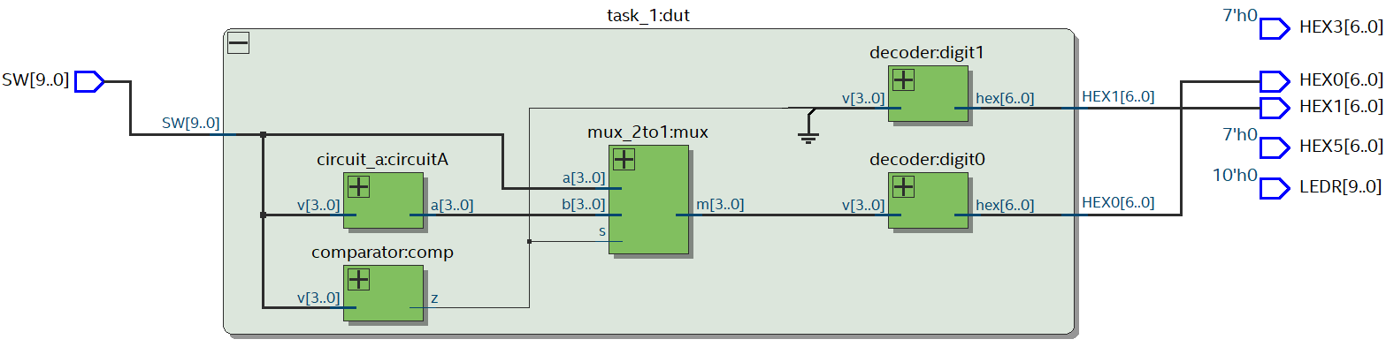

To test the desired functioning of the circuit, we implement the following testbench:

module *t1_tb* (); // testbench for task 1

   reg [9:0] SW;

   wire [6:0] HEX0, HEX1;

*task_1* dut (

       .SW  (SW),

       .HEX0(HEX0),

       .HEX1(HEX1)

   );

   initial begin

      SW = 10'bXXXXXX_0101;

      #10;

      SW = 10'bXXXXXX_0110;

      #10;

      SW = 10'bXXXXXX_1111;

      #10;

      SW = 10'bXXXXXX_1001;

      #10;

   end

endmodule



Following are sample hardware demonstrations of Part I on the DE-10 board:

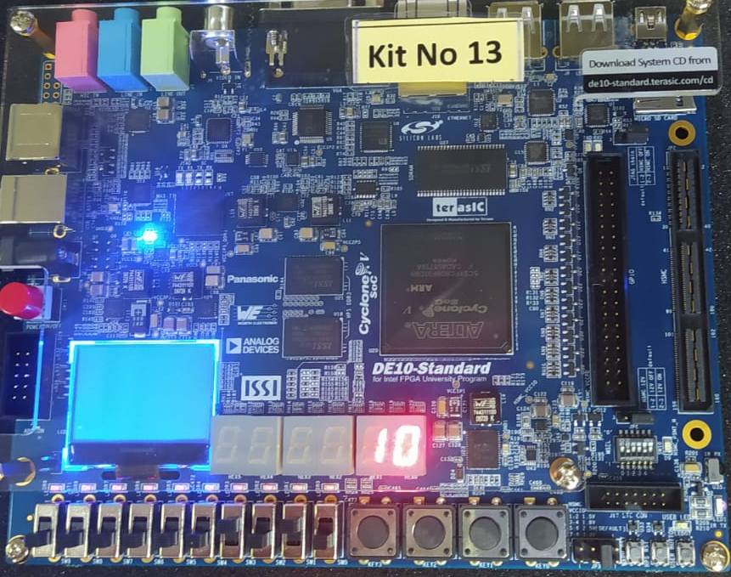 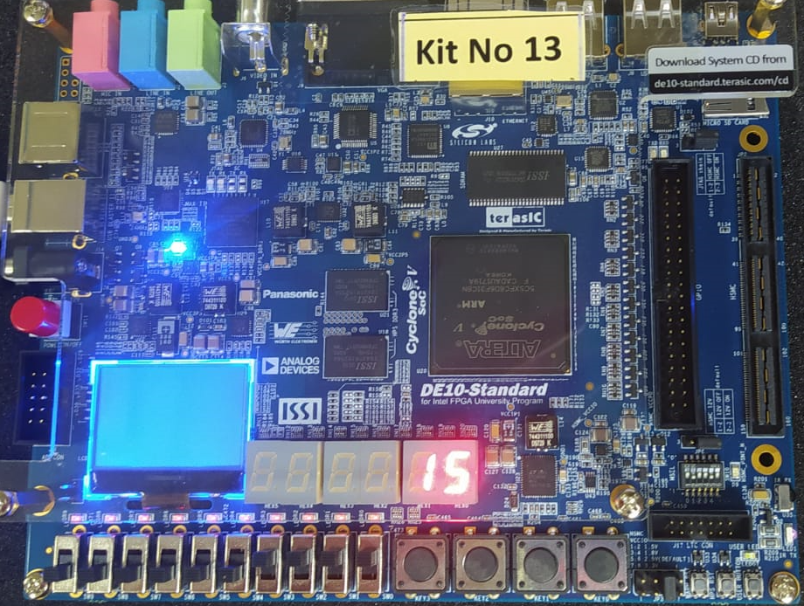

## Part II

Figure 2a shows a circuit for a full adder, which has the inputs a, b, and ci, and produces the outputs s and co. Parts b and c of the figure show a circuit symbol and truth table for the full adder, which produces the two-bit binary sum cos = a + b + ci. Figure 2d shows how four instances of this full adder module can be used to design a circuit that adds two four-bit numbers. This type of circuit is usually called a ripple-carry adder, because of the way that the carry signals are passed from one full adder to the next. Write Verilog code that implements this circuit, as described below.

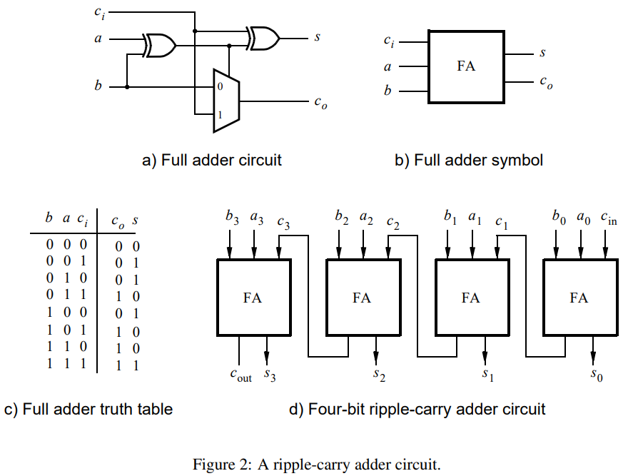

1. Create a new Quartus project for the adder circuit. Write a Verilog module for the full adder subcircuit and write a top-level Verilog module that instantiates four instances of this full adder.
2. Use switches SW7−4 and SW3−0 to represent the inputs A and B, respectively. Use SW8 for the carry-in cin of the adder. Connect the outputs of the adder, cout and S, to the red lights LEDR.
3. Include the necessary pin assignments for your DE-series board, compile the circuit, and download it into the FPGA chip.
4. Test your circuit by trying different values for numbers A, B, and cin.

module *fulladder* (

*input*  c_in,

*input*  a,

*input*  b,

*output* s,

*output* c_out

);

   wire x_s;

   assign x_s = a ^ b;

   assign s   = c_in ^ x_s;

*mux_2to1* #(

       .n(0)

   ) mux (

       .s(x_s),

       .a(b),

       .b(c_in),

       .m(c_out)

   );

endmodule

module *task_2* (

*input*  [9:0] SW,

*output* [9:0] LEDR

);

   wire [3:0] a = SW[3:0];

   wire [3:0] b = SW[7:4];

   wire [3:0] s;

   wire [4:0] c;

   genvar i;

   assign c[0]  = SW[8];

   assign c_out = c[4];

   generate

      for (i = 0; i < 4; i = i + 1) begin : stage

*fulladder* add (

             .c_in(c[i]),

             .a(a[i]),

             .b(b[i]),

             .s(s[i]),

             .c_out(c[i+1])

         );

      end

   endgenerate

   assign LEDR[3:0] = s[3:0];

   assign LEDR[4]   = c_out;

endmodule

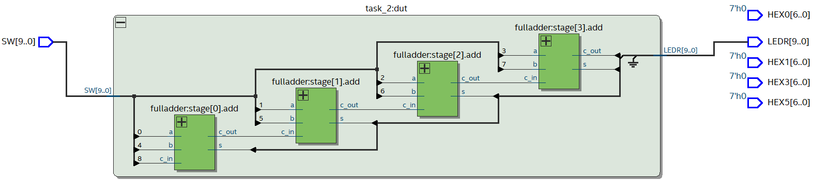

To test the desired functioning of the circuit, we implement the following testbench:

module *t2_tb* ();

   reg  [9:0] SW;

   wire [9:0] LEDR;

*task_2* test (

       .SW  (SW),

       .LEDR(LEDR)

   );

   initial begin

      SW = 10'bX_0_0010_0101;

      #10;

      SW = 10'bX_1_0010_0101;

      #10;

      SW = 10'bX_0_0010_1111;

      #10;

      SW = 10'bX_1_1001_1001;

      #10;

   end

endmodule



Following are sample hardware demonstrations of Part II on the DE-10 board:

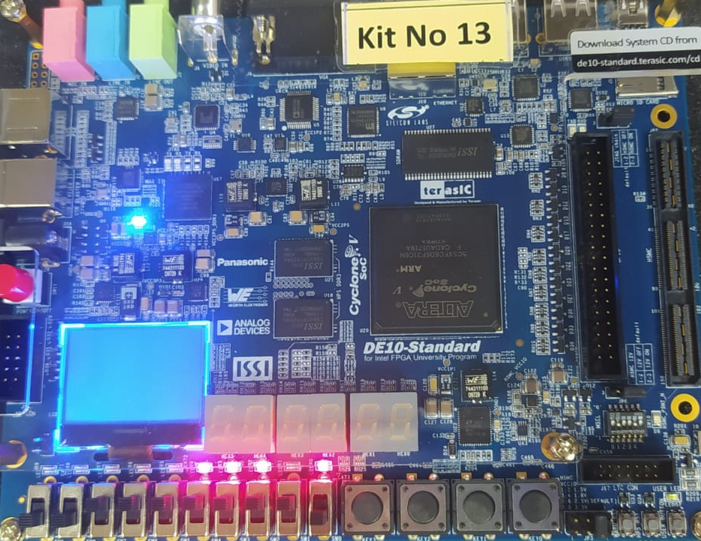 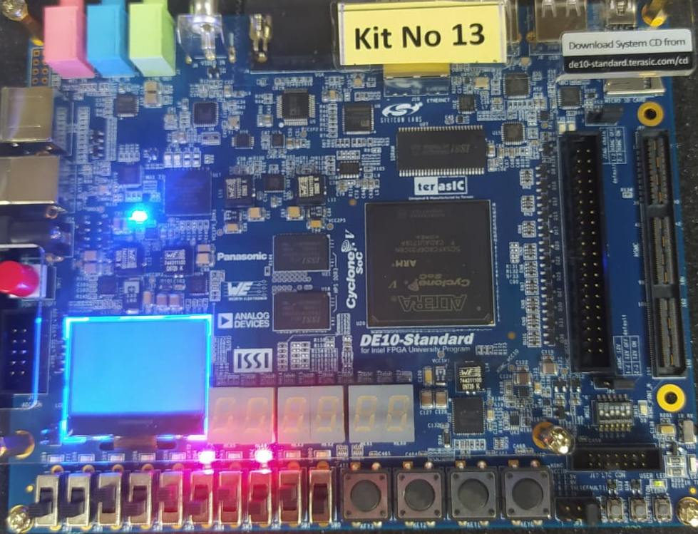

## Part III

In part II we discussed the conversion of binary numbers into decimal digits. For this part you are to design a circuit that has two decimal digits, X and Y, as inputs. Each decimal digit is represented as a 4-bit number. In technical literature this is referred to as the binary coded decimal (BCD) representation. You are to design a circuit that adds the two BCD digits. The inputs to your circuit are the numbers X and Y, plus a carry-in, cin. When these inputs are added, the result will be a 5-bit binary number. But this result is to be displayed on 7-segment displays as a two-digit BCD sum S1S0. For a sum equal to zero you would display S1S0 = 00, for a sum of one S1S0 = 01, for nine S1S0 = 09, for ten S1S0 = 10, and so on. Note that the inputs X and Y are assumed to be decimal digits, which means that the largest sum that needs to be handled by this circuit is S1S0 = 9 + 9 + 1 = 19.

1. Create a new Quartus project for your BCD adder. Write your Verilog code using simple assign statements to specify the required logic functions–do not use other types of Verilog statements such as if-else or case statements for this part of the exercise.
2. Use switches SW7−4 and SW3−0 for the inputs X and Y, respectively, and use SW8 for the carry-in. Connect the four-bit sum and carry-out produced by the operation X + Y to the red lights LEDR. Display the BCD values of X and Y on the 7-segment displays HEX5 and HEX3 and display the result S1S0 on HEX1 and HEX0.
3. Since your circuit handles only BCD digits, check for the cases when the input X or Y is greater than nine. If this occurs, indicate an error by turning on the red light LEDR9.
4. Include the necessary pin assignments for your DE-series board, compile the circuit, and download it into the FPGA chip.
5. Test your circuit by trying different values for numbers X, Y, and cin.

module *task_3* (

*input*  [9:0] SW,

*output* [9:0] LEDR,

*output* [6:0] HEX0,

*output* [6:0] HEX1,

*output* [6:0] HEX3,

*output* [6:0] HEX5

);

   wire [4:0] s;

   wire [3:0] x = SW[3:0];

   wire [3:0] y = SW[7:4];

   wire [3:0] m, a, z;

   wire c_in = SW[8];

   wire c_out;

   wire err;

   assign z[3:1] = 3'b000;

*fulladder_4bit* adder (

       .a(x),

       .b(y),

       .c_in(c_in),

       .s(s),

       .c_out(c_out)

   );

   assign s[4] = c_out;

*t3_circuit_a* circuitA (

       .s(s),

       .a(a)

   );

*t3_comparator* comp (

       .v(s),

       .z(z[0])

   );

*mux_2to1* #(

       .n(3)

   ) mux (

       .a(s[3:0]),

       .b(a),

       .s(z[0]),

       .m(m)

   );

*decoder* digit0 (.v (m), .hex(HEX0));

*decoder* digit1 (.v (z), .hex(HEX1));

*decoder* digit3 (.v (x), .hex(HEX3));

*decoder* digit5 (.v (y), .hex(HEX5));

*invalid_input* err_led (

       .x  (x),

       .y  (y),

       .err(err)

   );

   assign LEDR[9] = err;

endmodule

module *fulladder_4bit* (

*input* [3:0] a,

*input* [3:0] b,

*input* c_in,

*output* [3:0] s,

*output* c_out

);

   genvar i;

   wire [4:0] c;

   assign c_out = c[4];

   assign c[0]  = c_in;

   generate

      for (i = 0; i < 4; i = i + 1) begin : stage

*fulladder* add (

             .c_in(c[i]),

             .a(a[i]),

             .b(b[i]),

             .s(s[i]),

             .c_out(c[i+1])

         );

      end

   endgenerate

endmodule

module *t3_comparator* (

*input* [4:0] v,

*output* z

);

   assign z = (v[3] & (v[2] | v[1])) | v[4];

endmodule

module *invalid_input* (

*input* [3:0] x,

*input* [3:0] y,

*output* err

);

   assign err = (x[3] & (x[2] | x[1])) | (y[3] & (y[2] | y[1]));

endmodule

module *t3_circuit_a* (

*input*  [4:0] s,

*output* [3:0] a

);

   assign a[3] = ~s[3] & s[1];

   assign a[2] = (~s[3] & ~s[1]) & (s[2] & s[1]);

   assign a[1] = ~s[1];

   assign a[0] = s[0];

endmodule

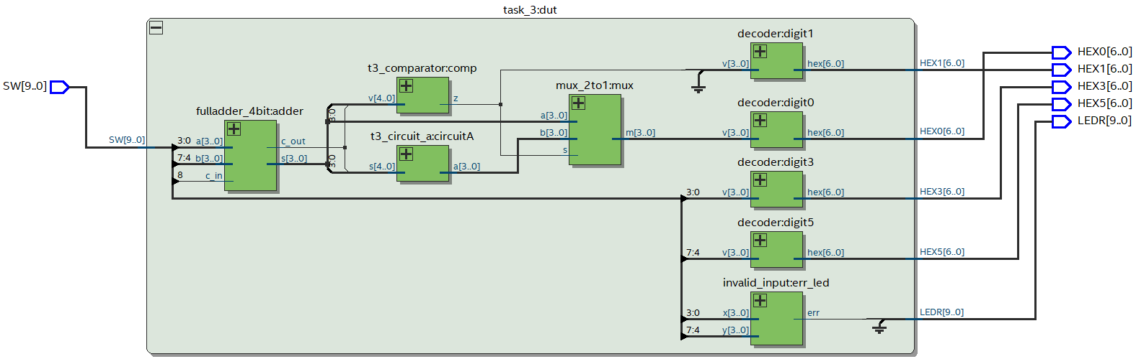

To test the desired functioning of the circuit, we implement the following testbench:

module *t3_tb* ();

   reg  [9:0] SW;

   wire [9:0] LEDR;

   wire [6:0] HEX0, HEX1, HEX3, HEX5;

*task_3* test (

       .SW  (SW),

       .LEDR(LEDR),

       .HEX0(HEX0),

       .HEX1(HEX1),

       .HEX3(HEX3),

       .HEX5(HEX5)

   );

   initial begin

      SW = 10'bX_0_0010_0101;

      #10;

      SW = 10'bX_1_0010_0101;

      #10;

      SW = 10'bX_0_0010_1111;

      #10;

      SW = 10'bX_1_1001_1001;

      #10;

   end

endmodule

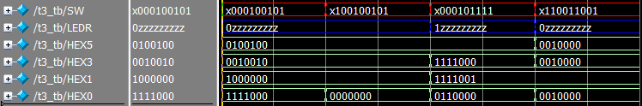

Following are sample hardware demonstrations of Part III on the DE-10 board:

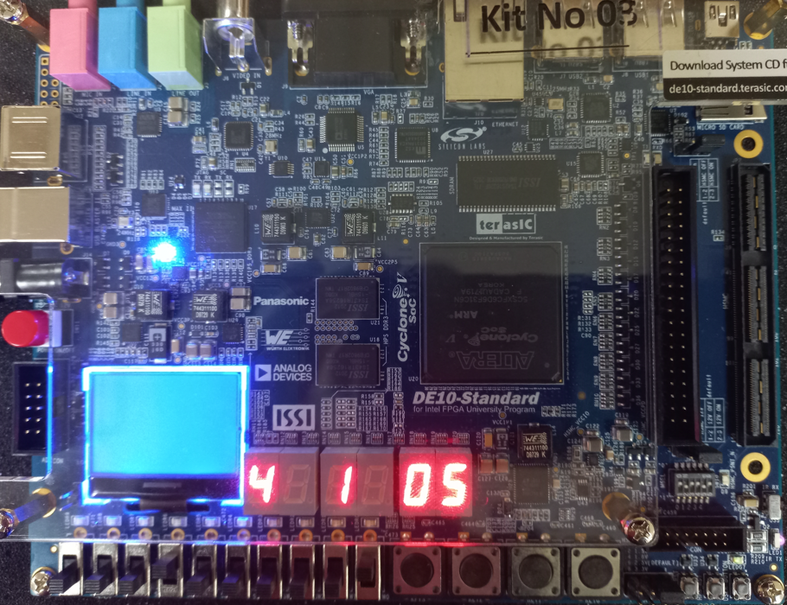 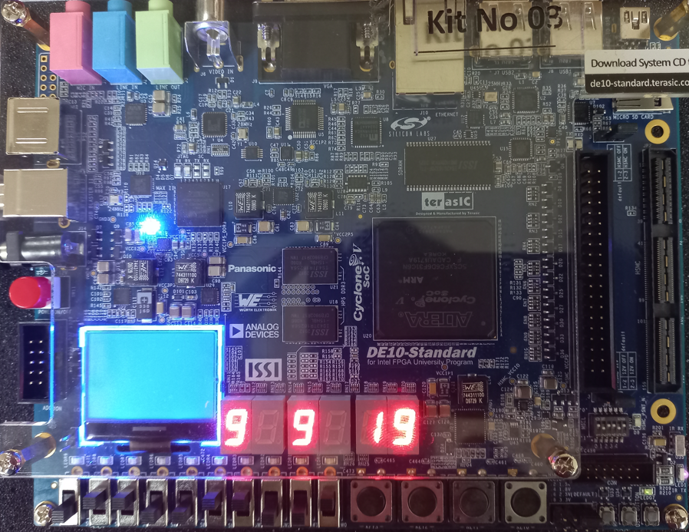

## Part IV

In part IV you created Verilog code for a BCD adder. A different approach for describing the adder in Verilog code is to specify an algorithm like the one represented by the following pseudo-code:

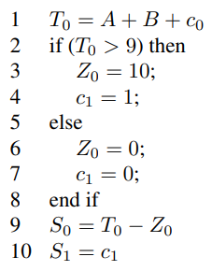

1. Create a new Quartus project for your Verilog code. Use switches SW7−4 and SW3−0 for the inputs A and B, respectively, and use SW8 for the carry-in. The value of A should be displayed on the 7-segment display HEX5, while B should be on HEX3. Display the BCD sum, S1S0, on HEX1 and HEX0.
2. Use the Quartus RTL Viewer tool to examine the circuit produced by compiling your Verilog code. Compare the circuit to the one you designed in Part IV.
3. Download your circuit onto your DE-series board and test it by trying different values for numbers A and B.

module *task_4* (

*input*  [9:0] SW,

*output* [6:0] HEX0,

*output* [6:0] HEX1,

*output* [6:0] HEX3,

*output* [6:0] HEX5

);

   wire [4:0] total;

   wire [3:0] x = SW[3:0];

   wire [3:0] y = SW[7:4];

   wire c_in = SW[8];

   reg [3:0] s1, s0, z;

   assign total = x + y + c_in;

   always @(*) begin

      s1[3:1] = 3'b000;

      if (total > 9) begin

         z = 10;

         s1[0] = 1;

      end else begin

         z = 0;

         s1[0] = 0;

      end

      s0 = total - z;

   end

*decoder* digit0 (.v (s0), .hex(HEX0));

*decoder* digit1 (.v (s1), .hex(HEX1));

*decoder* digit3 (.v (x), .hex(HEX3));

*decoder* digit5 (.v (y), .hex(HEX5));

endmodule

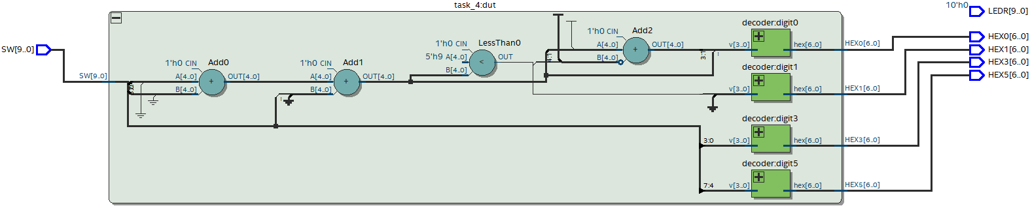

To test the desired functioning of the circuit, we implement the following testbench:

module *t4_tb* ();

   reg [9:0] SW;

   wire [6:0] HEX0, HEX1, HEX3, HEX5;

*task_4* test (

       .SW  (SW),

       .HEX0(HEX0),

       .HEX1(HEX1),

       .HEX3(HEX3),

       .HEX5(HEX5)

   );

   initial begin

      SW = 10'bX_0_0010_0101;

      #10;

      SW = 10'bX_1_0010_0101;

      #10;

      SW = 10'bX_0_0010_1111;

      #10;

      SW = 10'bX_1_1001_1001;

      #10;

   end

endmodule

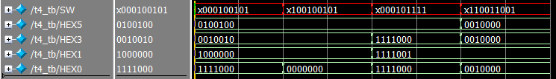

Following are sample hardware demonstrations of Part IV on the DE-10 board:

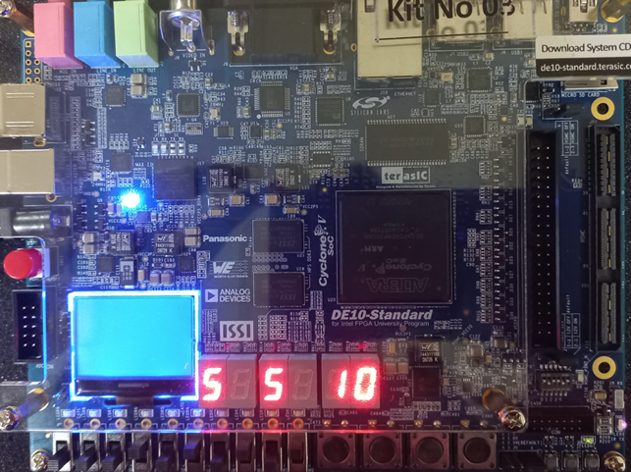 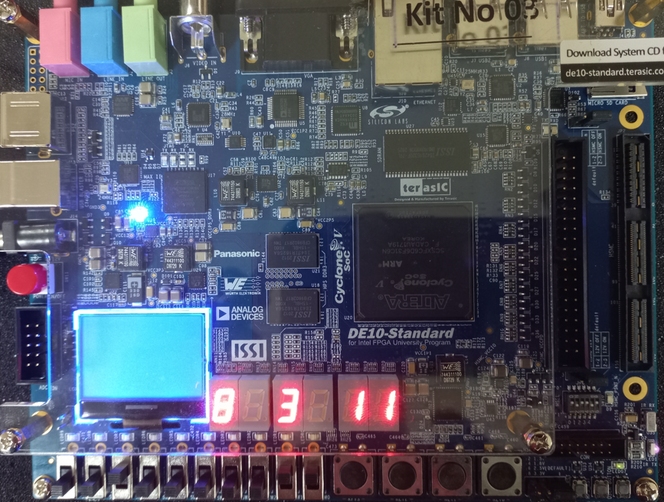

# Conclusion

In conclusion, this lab exercise has provided us with a practical understanding of combination circuits and their building blocks. We have learned how to design and implement combinational circuits that can perform binary-to-decimal number conversion and binary-coded-decimal (BCD) addition using switches as inputs and LEDs and 7-segment displays as output devices. Overall, this lab exercise has been a valuable learning experience, providing us with hands-on experience with combination circuits and their building blocks. It has also given us a foundation for further exploration and experimentation in the field of digital electronics.